**This homework’s main work is that it not only gives out the total steps, but also gives out the walk step and running step respectively by first clustering and classifying and applying different filter to running and walking. I tried two filter ways (detrend and Butterworth filter) and three peaks detection algorithm.**

**(A)Clustering and Classification**

a) Aim: Using K-MEANS clustering and the model trained by GNB in Q1 to see when is the person running and when is walking. Thus, I can apply different filter to walking and running respectively.

b)K-Means Code: 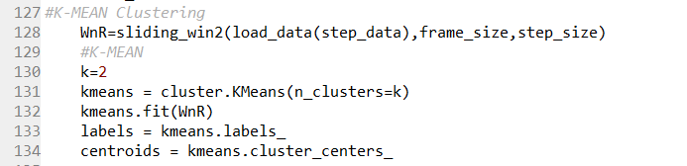

c) GNB classifier code:

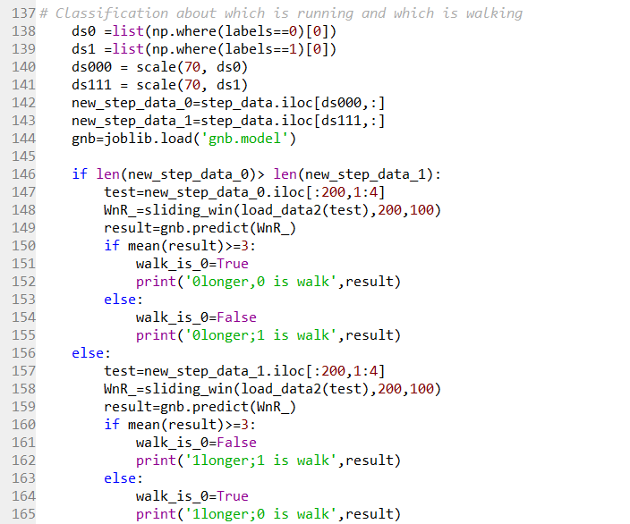

d) Results:

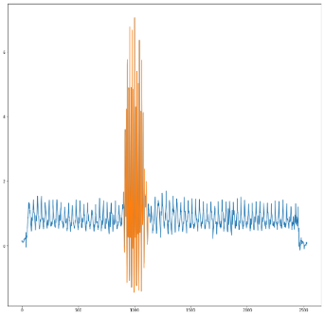

**(C) Filtering**

**Detrend**

**Butterworth low-pass filter:**

For running:

The highest frequency of people running is below 5HZ; Wn=2*fc/fs= 2*5/30=0.3333

For walking:

Wn=0.2

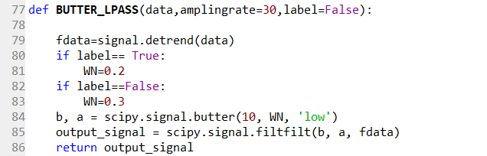

**(D)Find Peaks:**

**a)Arglmax/argrelmin**

The result is not good enough

C:\Users\70508\AppData\Local\Temp\1538203803(1).png

**b)Scipy.signal.find_peaks** 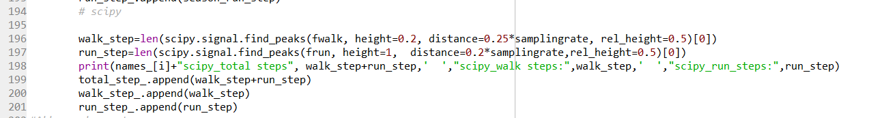

**c) Signal decomposition**

Signal decomposition seems to be more stable. But I am not sure what is its frequency.

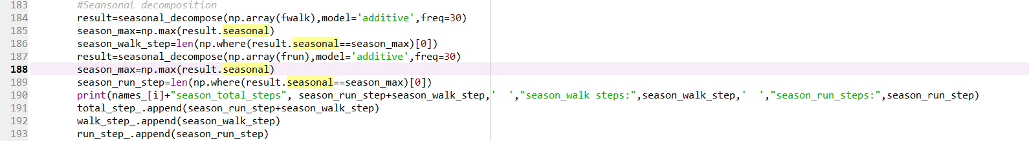

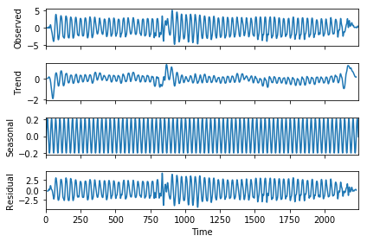

**E)results:**

professor’s steps

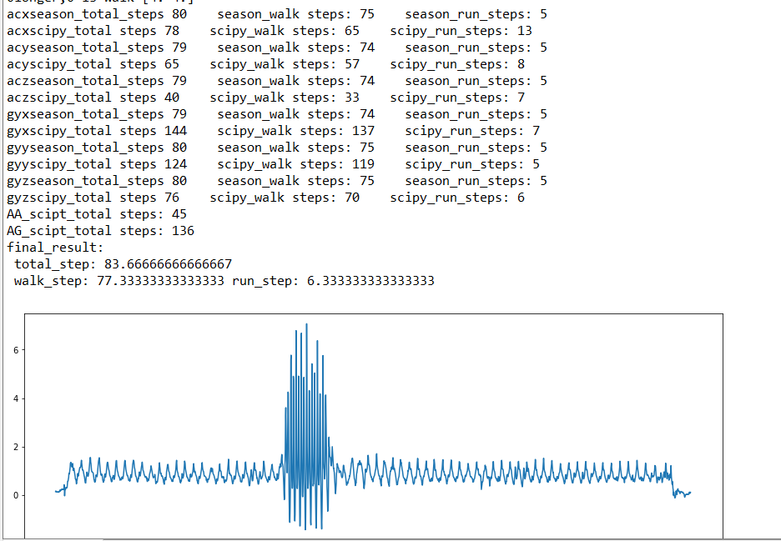

Accuracy:

total step: 83.1% , walk step: 86.1%; run step: 66.7%

My steps

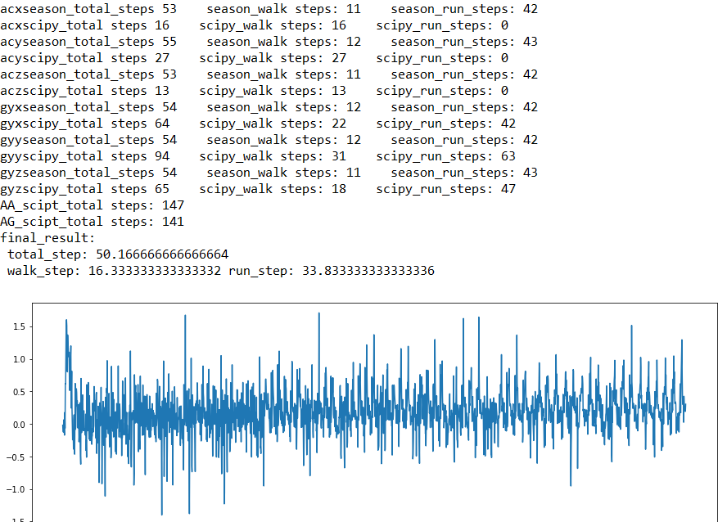

Accuracy: I can’t tell the ground truth.

The algorithm is not accuracy enough at present.

**(F) Future work**

Try Dynamic Time wrap